1. Q. What are breakpoints and why are they relevant?
2. developers.google.com defines breakpoints as:  "A breakpoint lets you pause your code in the middle of its execution, and examine all values at that moment in time." They are relevant because they allow the developer to make adjustments faster than the console.log () method. Additionally, with a breakpoint, DevTools show you the value of all variables at that moment so you know what variable(s) are affecting your code and what you need to do to fix it. With console.log (), you’ll need to open the source code, find the relevant code, insert the console.log () statements, and then reload the page in order to see the messages in the Console. This is a very timely method which developer can still mistakenly overlook errors.
3. 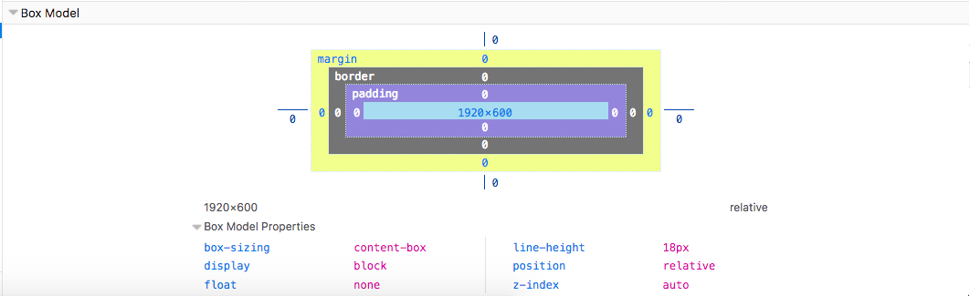Q. Which set of DevTools (Chrome/Firefox) is better and why (provide at least three examples)?  
     
   A. In my opinion, Firefox DevTools are better because it offers better features. For example: In the Inspector tab, in the left window, there’s a tab named “Layout”. It shows you a Box Model of the webpage which shows you all the properties of the page itself. This allows the developer to quickly make changes to the webpage in regards to box-sizing, display, float, line-height, position, and z-index.

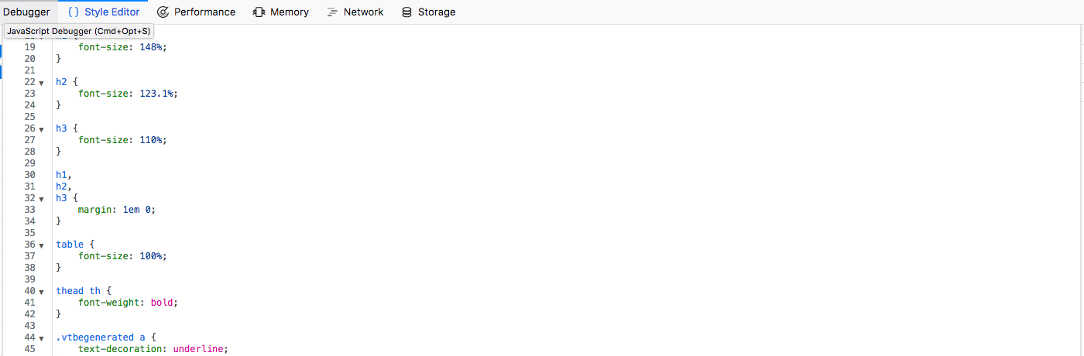Additionally, in the Style Editor tab, you’ll see all the CSS-styling for the webpage. This makes it easier for the developer to make styling changes to the webpage without having to go to their text editor, make the changes, save the changes, reload the webpage, and repeat. Editing is quick and effortless.

Lastly, I feel that Firefox DevTools are better because it’s easier to use and look a lot cleaner and less convoluted. I feel everything is easier to find and I don’t feel confused by what I see in the menus. In the Inspector tab, the HTML document is laid out cleanly with down arrows so you can meticulously select what you want to edit.